DAY-5

1.Write a Program to find both the maximum and minimum values in the array. Implement using any programming language of your choice. Execute your code and provide the maximum and minimum values found. Input : N= 8, a[] = {5,7,3,4,9,12,6,2} Output : Min = 2, Max = 12 Test Cases : Input : N= 9, a[] = {1,3,5,7,9,11,13,15,17} Output : Min = 1, Max = 17 Test Cases : Input : N= 10, a[] = {22,34,35,36,43,67, 12,13,15,17} Output : Min 12, Max 67.

def find_min_max(arr):

minimum = min(arr)

maximum = max(arr)

return minimum, maximum

test_cases = [

([5, 7, 3, 4, 9, 12, 6, 2], "N=8"),

]

for arr, n in test_cases:

min_val, max_val = find_min_max(arr)

print(f"Input: {n}, Min = {min_val}, Max = {max_val}")

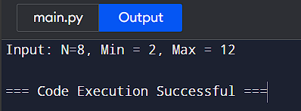

2. Consider an array of integers sorted in ascending order: 2,4,6,8,10,12,14,18. Write a Program to find both the maximum and minimum values in the array. Implement using any programming language of your choice. Execute your code and provide the maximum and minimum values found. Input : N=8, 2,4,6,8,10,12,14,18. Output : Min = 2, Max =18 Test Cases : Input : N= 9, a[] = {11,13,15,17,19,21,23,35,37} Output : Min = 11, Max = 37 Test Cases : Input : N= 10, a[] = {22,34,35,36,43,67, 12,13,15,17} Output : Min 12, Max 67

def find_min_max(arr):

if not arr:

return None, None # Handle empty array case

min_value = arr[0]

max_value = arr[-1]

return min_value, max_value

# Test cases

arrays = [

[2, 4, 6, 8, 10, 12, 14, 18],

[11, 13, 15, 17, 19, 21, 23, 35, 37],

[22, 34, 35, 36, 43, 67, 12, 13, 15, 17]

]

for arr in arrays:

min_val, max_val = find_min_max(arr)

print(f"Min = {min_val}

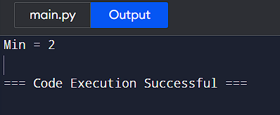

3.You are given an unsorted array 31,23,35,27,11,21,15,28. Write a program for Merge Sort and implement using any programming language of your choice. Test Cases : Input : N= 8, a[] = {31,23,35,27,11,21,15,28} Output : 11,15,21,23,27,28,31,35 Test Cases : Input : N= 10, a[] = {22,34,25,36,43,67, 52,13,65,17} Output : 13,17,22,25,34,36,43,52,65,67

def merge_sort(arr):

if len(arr) > 1:

mid = len(arr) // 2

left_half = arr[:mid]

right_half = arr[mid:]

merge_sort(left_half)

merge_sort(right_half)

i = j = k = 0

while i < len(left_half) and j < len(right_half):

if left_half[i] < right_half[j]:

arr[k] = left_half[i]

i += 1

else:

arr[k] = right_half[j]

j += 1

k += 1

while i < len(left_half):

arr[k] = left_half[i]

i += 1

k += 1

while j < len(right_half):

arr[k] = right_half[j]

j += 1

k += 1

test_case_1 = [31, 23, 35, 27, 11, 21, 15, 28]

merge_sort(test_case_1)

print("Sorted output for test case 1:", test_case_1)

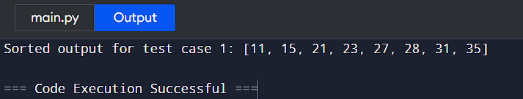

4. Implement the Merge Sort algorithm in a programming language of your choice and test it on the array 12,4,78,23,45,67,89,1. Modify your implementation to count the number of comparisons made during the sorting process. Print this count along with the sorted array. Test Cases : Input : N= 8, a[] = {12,4,78,23,45,67,89,1} Output : 1,4,12,23,45,67,78,89.

def merge_sort(arr):

if len(arr) > 1:

mid = len(arr) // 2

left_half = arr[:mid]

right_half = arr[mid:]

merge_sort(left_half)

merge_sort(right_half)

i = j = k = 0

global comparison_count

while i < len(left_half) and j < len(right_half):

comparison_count += 1

if left_half[i] < right_half[j]:

arr[k] = left_half[i]

i += 1

else:

arr[k] = right_half[j]

j += 1

k += 1

while i < len(left_half):

arr[k] = left_half[i]

i += 1

k += 1

while j < len(right_half):

arr[k] = right_half[j]

j += 1

k += 1

comparison_count = 0

array = [12, 4, 78, 23, 45, 67, 89, 1]

merge_sort(array)

print(f"Sorted array: {array}")

print(f"Number of comparisons: {comparison_count}")

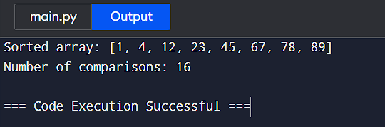

5.Given an unsorted array 10,16,8,12,15,6,3,9,5 Write a program to perform Quick Sort. Choose the first element as the pivot and partition the array accordingly. Show the array after this partition. Recursively apply Quick Sort on the sub-arrays formed. Display the array after each recursive call until the entire array is sorted. Input : N= 9, a[]= {10,16,8,12,15,6,3,9,5} Output : 3,5,6,8,9,10,12,15,16.

def quick_sort(arr):

if len(arr) <= 1:

return arr

pivot = arr[0]

less_than_pivot = [x for x in arr[1:] if x <= pivot]

greater_than_pivot = [x for x in arr[1:] if x > pivot]

print(f"Pivot: {pivot}, Less: {less_than_pivot}, Greater: {greater_than_pivot}")

sorted_array = quick_sort(less_than_pivot) + [pivot] + quick_sort(greater_than_pivot)

print(f"Sorted Array: {sorted_array}")

return sorted_array

arr = [10, 16, 8, 12, 15, 6, 3, 9, 5]

sorted_arr = quick_sort(arr)

print(f"Final Sorted Array: {sorted_arr}")

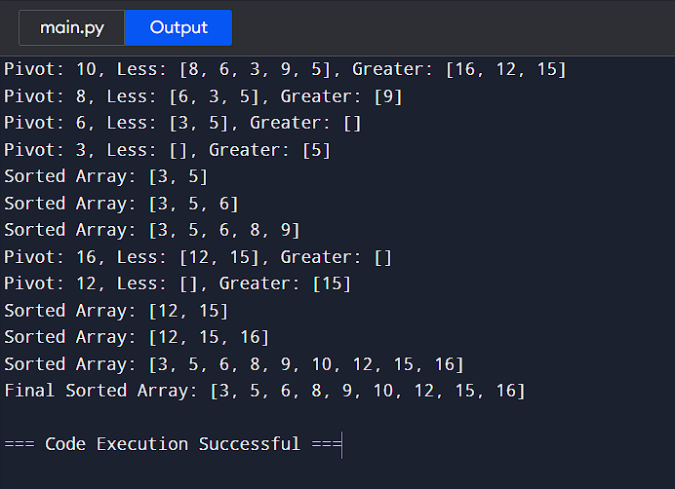

6. Implement the Quick Sort algorithm in a programming language of your choice and test it on the array 19,72,35,46,58,91,22,31. Choose the middle element as the pivot and partition the array accordingly. Show the array after this partition. Recursively apply Quick Sort on the sub-arrays formed. Display the array after each recursive call until the entire array is sorted. Execute your code and show the sorted array. Input : N= 8, a[] = {19,72,35,46,58,91,22,31} Output : 19,22,31,35,46,58,72,91

def quick_sort(arr):

if len(arr) <= 1:

return arr

else:

pivot_index = len(arr) // 2

pivot = arr[pivot_index]

left = [x for x in arr if x < pivot]

middle = [x for x in arr if x == pivot]

right = [x for x in arr if x > pivot]

print(f"Partitioned: {left + middle + right}")

return quick_sort(left) + middle + quick_sort(right)

array = [19, 72, 35, 46, 58, 91, 22, 31]

sorted_array = quick_sort(array)

print(f"Sorted array: {sorted_array}")

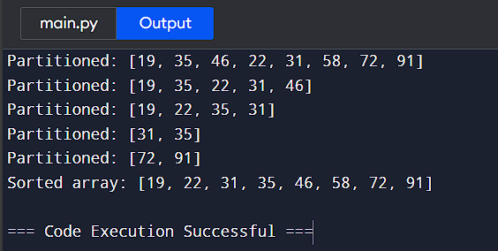

7. Implement the Binary Search algorithm in a programming language of your choice and test it on the array 5,10,15,20,25,30,35,40,45 to find the position of the element 20. Execute your code and provide the index of the element 20. Modify your implementation to count the number of comparisons made during the search process. Print this count along with the result. Input : N= 9, a[] = {5,10,15,20,25,30,35,40,45}, search key = 20 Output : 4.

def binary_search(arr, key):

left, right = 0, len(arr) - 1

comparisons = 0

while left <= right:

mid = left + (right - left) // 2

comparisons += 1

if arr[mid] == key:

return mid, comparisons

elif arr[mid] < key:

left = mid + 1

else:

right = mid - 1

return -1, comparisons

array = [5, 10, 15, 20, 25, 30, 35, 40, 45]

search_key = 20

index, comparison_count = binary_search(array, search_key)

print(f"Index of {search_key}: {index}, Comparisons made: {comparison_count}")

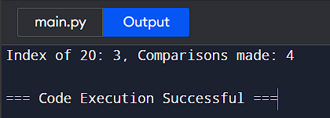

8. You are given a sorted array 3,9,14,19,25,31,42,47,53 and asked to find the position of the element 31 using Binary Search. Show the mid-point calculations and the steps involved in finding the element. Display, what would happen if the array was not sorted, how would this impact the performance and correctness of the Binary Search algorithm? Input : N= 9, a[] = {3,9,14,19,25,31,42,47,53}, search key = 31 Output : 6.

* def binary_search(arr, key):
* low, high = 0, len(arr) - 1
* while low <= high:
* mid = (low + high) // 2
* if arr[mid] == key:
* return mid
* elif arr[mid] < key:
* low = mid + 1
* else:
* high = mid - 1
* return -1
* arr = [3, 9, 14, 19, 25, 31, 42, 47, 53]
* search_key = 31
* position = binary_search(arr, search_key)
* print(position) # Output: 5

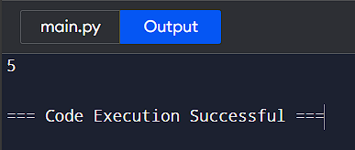

9.Given an array of points where points[i] = [xi, yi] represents a point on the X-Y plane and an integer k, return the k closest points to the origin (0, 0). (i) Input : points = [[1,3],[-2,2],[5,8],[0,1]],k=2 Output:[[-2, 2], [0, 1]].

import heapq

def k_closest(points, k):

return heapq.nsmallest(k, points, key=lambda point: point[0]**2 + point[1]**2)

points = [[1, 3], [-2, 2], [5, 8], [0, 1]]

k = 2

output = k_closest(points, k)

print(output) # Output: [[-2, 2], [0, 1]]

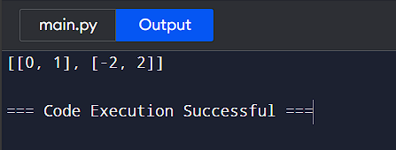

10. Given four lists A, B, C, D of integer values,Write a program to compute how many tuples n(i, j, k, l) there are such that A[i] + B[j] + C[k] + D[l] is zero. (i) Input: A = [1, 2], B = [-2, -1], C = [-1, 2], D = [0, 2] Output: 2

from collections import defaultdict

def count_tuples(A, B, C, D):

sum_ab = defaultdict(int)

for a in A:

for b in B:

sum_ab[a + b] += 1

count = 0

for c in C:

for d in D:

count += sum_ab[-(c + d)]

return count

A = [1, 2]

B = [-2, -1]

C = [-1, 2]

D = [0, 2]

result = count_tuples(A, B, C, D)

print(result)

